Musculoskeletal Series

Spinal Cord Rehabilitation –
from the Perspective of Physiotherapy
(Hybrid Mode : Classroom / Zoom)

Date: 13 Oct 2023 (Friday)
Time: 7:00pm – 9:00pm
Physical attendance : Conference Room, M/F, Kowloon Hospital Rehab Building /
through zoom

Speaker : Mr. Angus Law
Master of Philosophy (The University of Sheffield), England
Master of Physiotherapy (The University of Melbourne), Australia
Bachelor of Science in Physiotherapy (Hong Kong Polytechnic University), HK
Registered Physiotherapist (Hong Kong)

Fee : Free of Charge for member
CNE : 2 CNE Point by HKRNS (75% Attendance hours is required for Zoom Session)

Enrolment : Please scan the QR Code / click the below link for enrolment or complete the
attached enrolment form and return to us by fax
https://forms.gle/LcwBTt6k5ZEmsfir6
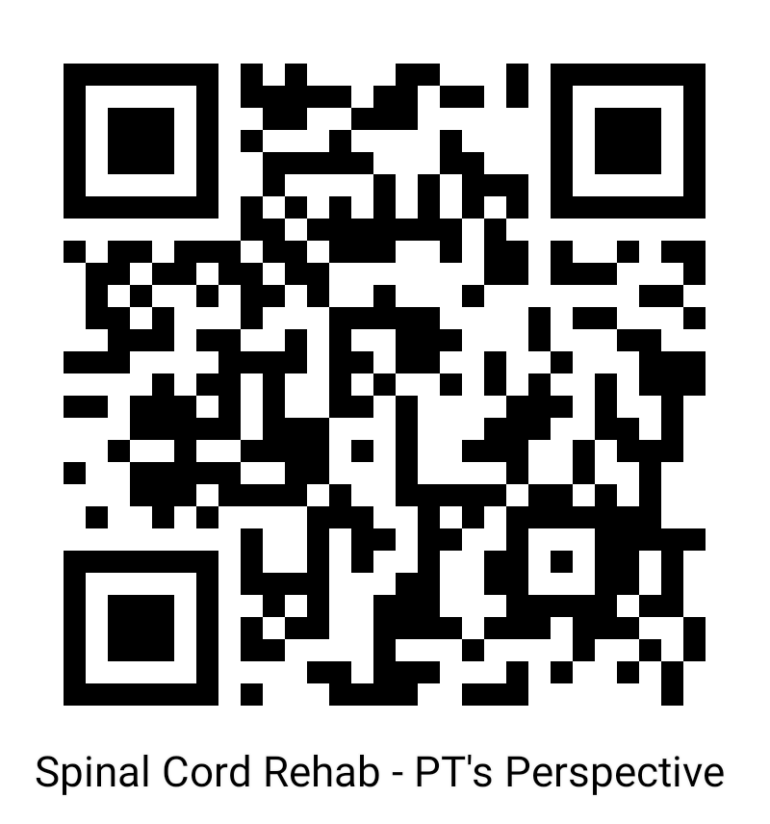

For those who are not yet a member of Hong Kong Rehab Nursing
Society, please Scan or Click the QR Code and join as a member.

↑Click here to join as member
Enrolment Form
Musculoskeletal series
Spinal Cord Rehabilitation –
from the Perspective of Physiotherapy
(Hybrid Mode : Classroom / Zoom)
Please Fax to 27622204 5B/KH

I would like to apply for the of the Seminar on : 13/10/2023
Spinal Cord Rehabilitation –
from the Perspective of Physiotherapy with the following mode (Please tick )
 Classroom  Zoom

Deadline : 6 Oct 2023
Name |  | Telephone:
E-mail Address |  | HKRNS Member *
Organization |  | Non-member*
Date |  | Signature
--------------------------------------------------------------------------------------
Enquiry:
Ms. Ann Chan 94292116
Ms. Angela Shiu 60105577
Mr. Walen Leung 90934759
Ms. Eva Chan 92277009
Ms. Man Hang Sim 92189552

