Musculoskeletal Series

Spinal Cord Rehabilitation –
from the Perspective of Occupational Therapy
(Hybrid Mode : Classroom / Zoom)

Date: 11 August 2023 (Friday)
Time: 7:00pm – 9:00pm
Venue : Conference Room, M/F, Kowloon Hospital Rehab Building /
Zoom

Speaker: Mr. To Tze Shing, Jess
SOT, KH,
PDip in OT
MSc.HC(OT), PgDip (Occupational Hygiene)
Certified Assistive Technology Practitioner

Fee : Free of Charge for member
CNE : 2 CNE Point by HKRNS (75% Attendance hours is required for Zoom Session)

Enrolment : Please scan the QR Code / click the below link for enrolment or complete the
attached enrolment form and return to us by fax
https://forms.gle/BGpyZ9XvE9dX5F8P7
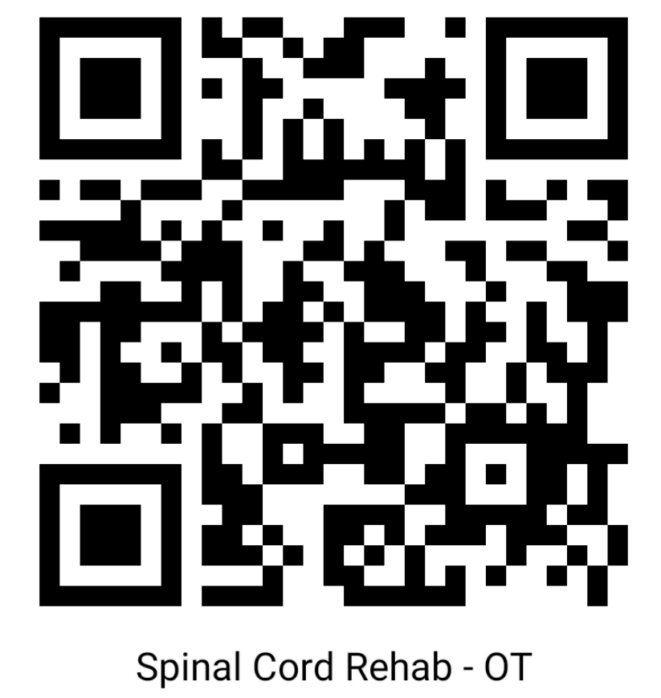

Join the HKRNS as member: For those who are not yet a member of Hong Kong Rehab Nursing
Society, please Scan the QR Code and join as a member.


Enrolment Form
Musculoskeletal series
Spinal Cord Rehabilitation –
from the Perspective of Occupational Therapy
(Hybrid Mode : Classroom / Zoom)
Please Fax to 27622204 5B/KH

I would like to apply for the of the Seminar on :
Spinal Cord Rehabilitation –
from the Perspective of Occupational Therapy with the following mode (Please tick )
 Classroom  Zoom

Deadline : 9 Aug 2023
Name |  | Telephone:
E-mail Address |  | HKRNS Member *
Organization |  | Non-member*
Date |  | Signature
--------------------------------------------------------------------------------------
Enquiry:
Ms. Ann Chan 94292116
Ms. Angela Shiu 60105577
Mr. Walen Leung 90934759
Ms. Eva Chan 92277009
Ms. Man Hang Sim 92189552

